Golf should be fun!
You should feel safe and enjoy your sport

Is something worrying you?
Do you need someone to talk to?

Speak to your club welfare officer
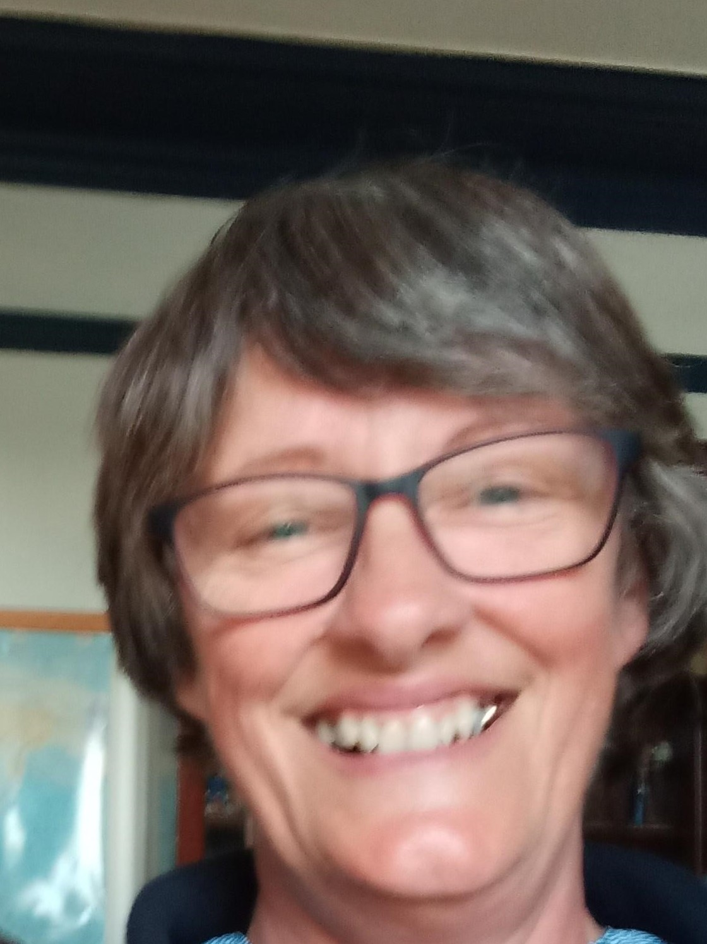

Club Welfare Officers Name:

Lesley Upperton

Email address:
Lesley_upperton6@hotmail.com

Telephone Number:

07815135933

Alternatively, you can speak to someone at
ChildLine 0800 1111 | NSPCC 0808 800 5000 | England Golf 01526 351851

